**Navdeep Singh**

**Id - 23094413**

**Test – 1B**

**Section A: Application Creation and Initial Screenshot (320 Marks)**

import javafx.application.Application;

import javafx.geometry.Insets;

import javafx.scene.Scene;

import javafx.scene.control.*;

import javafx.scene.layout.*;

import javafx.stage.Stage;

public class Main extends Application {

@Override

public void start(Stage primaryStage) {

// Labels with student info

Label nameLabel = new Label("Name: Navdeep Singh");

Label idLabel = new Label("Student ID: 23094413");

Label dateLabel = new Label("Date: 2025-06-19");

// Title

Label titleLabel = new Label("Login Page");

titleLabel.setStyle("-fx-font-size: 18px; -fx-font-weight: bold;");

// Username and Password fields

Label userLabel = new Label("Username:");

TextField usernameField = new TextField();

Label passLabel = new Label("Password:");

PasswordField passwordField = new PasswordField();

// Login button (no logic yet in Section A)

Button loginButton = new Button("Login");

// Layout

VBox infoBox = new VBox(5, nameLabel, idLabel, dateLabel);

VBox loginBox = new VBox(10, titleLabel, userLabel, usernameField, passLabel, passwordField, loginButton);

VBox mainLayout = new VBox(20, infoBox, loginBox);

mainLayout.setPadding(new Insets(20));

// Scene setup

Scene scene = new Scene(mainLayout, 350, 300);

primaryStage.setTitle("Navdeep Singh JavaFX Login App");

primaryStage.setScene(scene);

primaryStage.show();

}

public static void main(String[] args) {

launch(args);

}

}

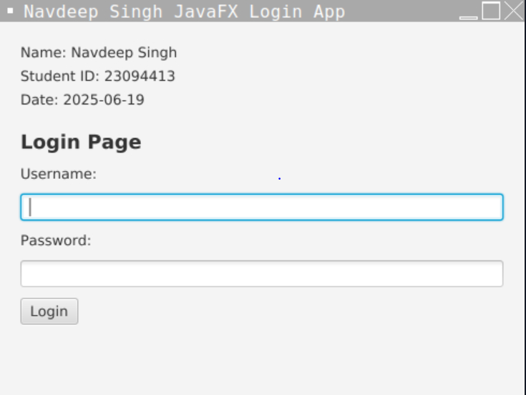

**Section B,C**

public class LoginController {

private int attempts = 0;

private final String correctUsername = "Navdeep";

private final String correctPassword = "456";

public String handleLogin(String username, String password) {

**Section- D**

public class User {

private String username;

private String password;

public User(String username, String password) {

this.username = username;

this.password = password;

}

public String getUsername() {

return username;

}

public void setUsername(String username) {

this.username = username;

}

public String getPassword() {

return password;

}

public void setPassword(String password) {

this.password = password;

}

}

**// Section E: Validation**

if (username.isEmpty() || password.isEmpty()) {

return "Please Provide Username or Password";

}

**// Section G: Lock after 5 failed attempts**

if (attempts >= 5) {

return "Sorry, Your Account is Locked!!!";

}

**// Section F & H: Static login logic and attempt count**

if (username.equals(correctUsername) && password.equals(correctPassword)) {

attempts = 0; // Reset on success

return "Success!!!";

} else {

attempts++;

return attempts >= 5 ?

"Sorry, Your Account is Locked!!!" :

"Sorry, Invalid Username or Password";

}

}

}

